The team met for an hour and made good progress on deliverable 3

-Wellness check

-Team worked on Deliverable 3

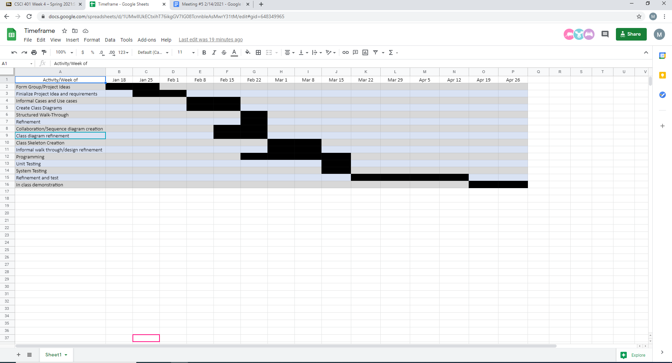

SRS Document below

https://docs.google.com/document/d/1-laRvPKKZClX_Hak0yoiAMYdnbRLlepzPL1OmA2qbNE/edit